## horizontal line



Note Web Application

04.09.2023

**─**

Akkhil

# Wannabe indiass

Kurukshetra, Haryana

# 

# Overview

* The project will consist of three files: an HTML file, a CSS file, and a JavaScript file.
* The HTML file will define the basic structure of the application, such as the layout of the notes and the buttons for adding, editing, and removing notes.
* The CSS file will style the elements of the application, such as the colors, fonts, and sizes of the text.
* The JavaScript file will manage the interactivity of the application, such as the logic for adding, editing, and removing notes.
* The notes will be saved locally on the device using the browser's Local Storage API.

# Goals

1. To create a note-app for students to take notes for study and to help teachers create a text format summary of a chapter
2. Also, to gain experience in the field of Web-development
3. To help create a project that can help in development of the future projects

# Specifications

There are three main software/environment you need in order to development this project

1. A code editor- A code editor is a software application that allows users to write and edit computer code. It typically supplies features such as syntax highlighting, autocompletion, and debugging. Some popular code editors include Visual Studio Code, Sublime Text, and Atom.
2. Node.js-**Node.js** is a [cross-platform](https://en.wikipedia.org/wiki/Cross-platform), [open-source](https://en.wikipedia.org/wiki/Open-source_software) server environment that can run on [Windows](https://en.wikipedia.org/wiki/Microsoft_Windows), [Linux](https://en.wikipedia.org/wiki/Linux), [Unix](https://en.wikipedia.org/wiki/Unix), [macOS](https://en.wikipedia.org/wiki/MacOS), and more. Node.js is a [back-end](https://en.wikipedia.org/wiki/Frontend_and_Backend) [JavaScript](https://en.wikipedia.org/wiki/JavaScript) [runtime environment](https://en.wikipedia.org/wiki/Runtime_system), runs on the [V8](https://en.wikipedia.org/wiki/V8_(JavaScript_engine)) [JavaScript engine](https://en.wikipedia.org/wiki/JavaScript_engine), and executes JavaScript code outside a [web browse](https://en.wikipedia.org/wiki/Web_browser)r.
3. Browser-A **Web browser** is an [application](https://en.wikipedia.org/wiki/Application_software) for accessing [websites](https://en.wikipedia.org/wiki/Website). When a [user](https://en.wikipedia.org/wiki/User_(computing)) requests a [web page](https://en.wikipedia.org/wiki/Web_page) from a particular website, the browser retrieves its [files](https://en.wikipedia.org/wiki/Computer_file) from a [web server](https://en.wikipedia.org/wiki/Web_server) and then displays the page on the user's screen.

# 

# Step By Step implement of each mentioned software/environment

## Code Editor- There are many code editor available in the market, you can chouse your preferred code editor.

My preferred code editor is Visual studio code here are the step to install Visual studio code

1. Open your preferred browser (Mine is chrome)

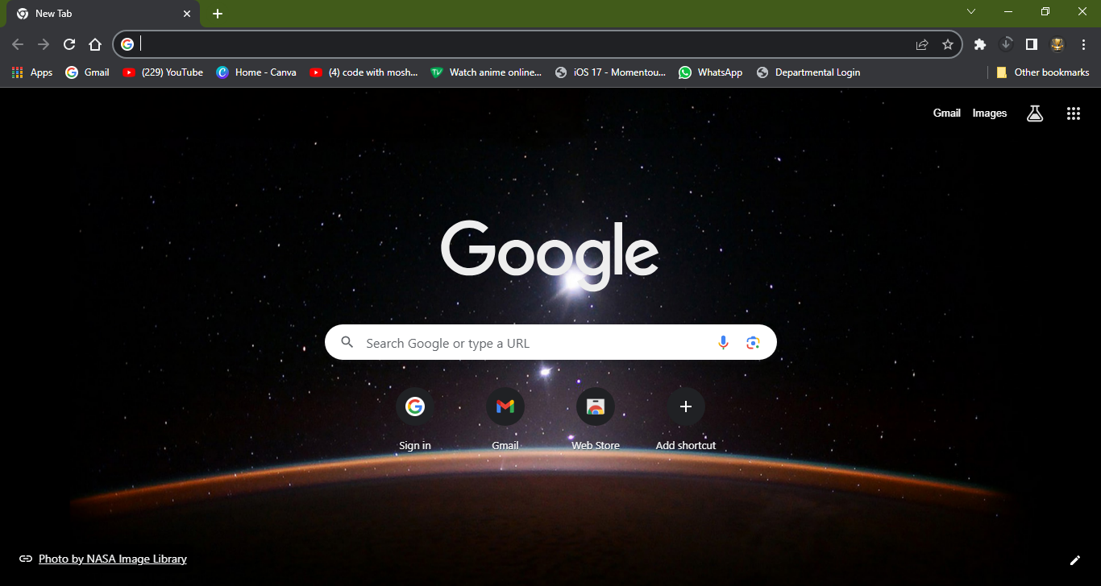

1. Go to <https://code.visualstudio.com/download> to download visual studio code

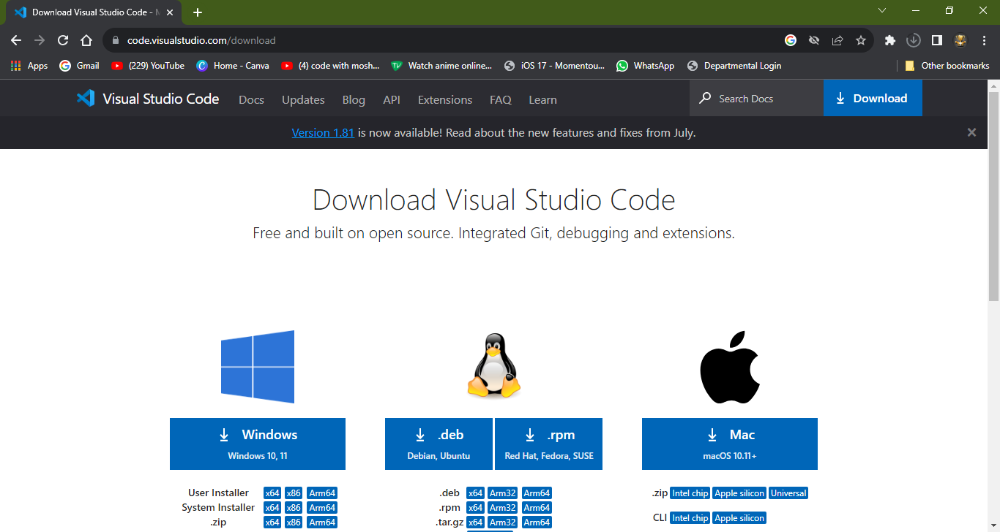

1. Download using the appropriate o.s usually its windows but your device may vary
2. When the download finishes, then the Visual Studio Code icon appears in the downloads folder.

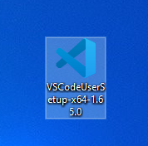

1. Click on the installer icon to start the installation process of the Visual Studio Code.
2. After the Installer opens, it will ask you for accepting the terms and conditions of the Visual Studio Code. Click on **I accept the agreement** and then clickthe **Next** button.

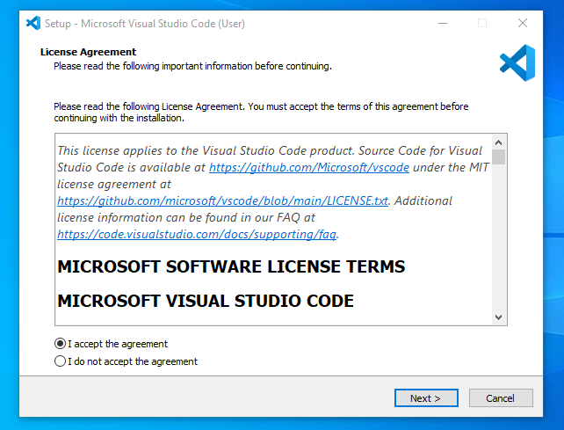

1. Choose the location data for running the Visual Studio Code. It will then ask you for browsing the location. Then click on **Next** button.

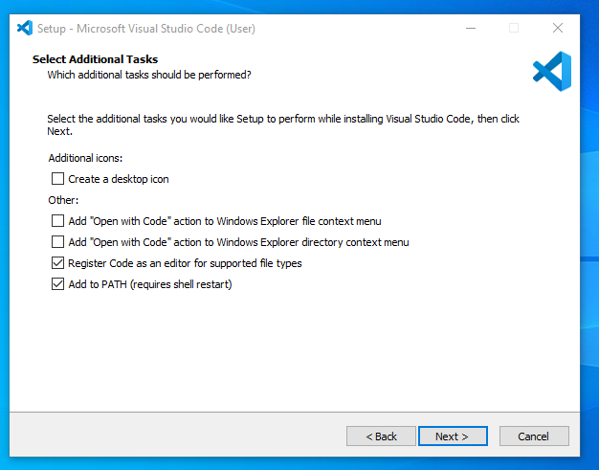

1. Then it will ask for beginning the installing setup. Click on the **Install** button.

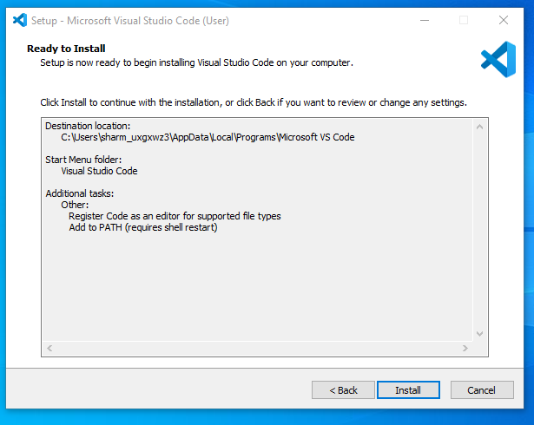

1. After clicking on Install, it will take about 1 minute to install the Visual Studio Code on your device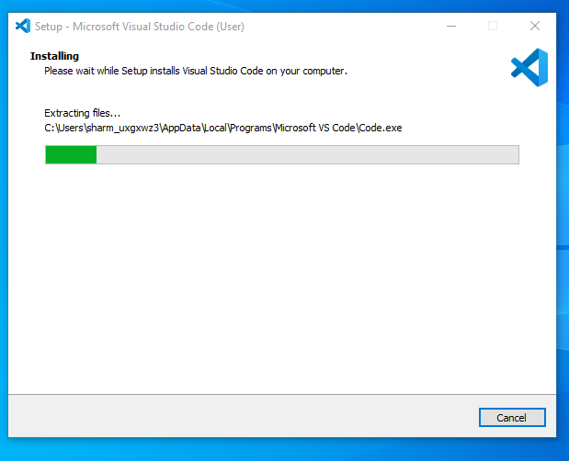
2. After the Installation setup for Visual Studio Code is finished, it will show a window like this below. Tick the “**Launch Visual Studio Code**” checkbox and then click **Finish**.

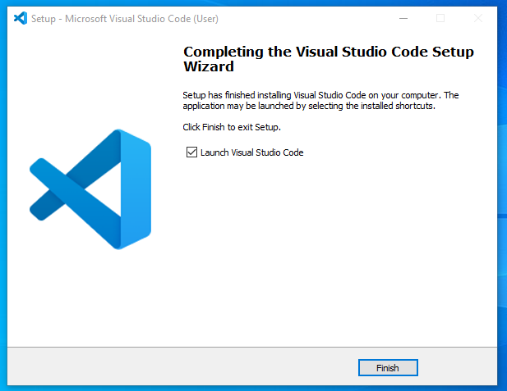

1. After the earlier step, the **Visual Studio Code window** opens successfully. Now you can create a new file in the Visual Studio Code window

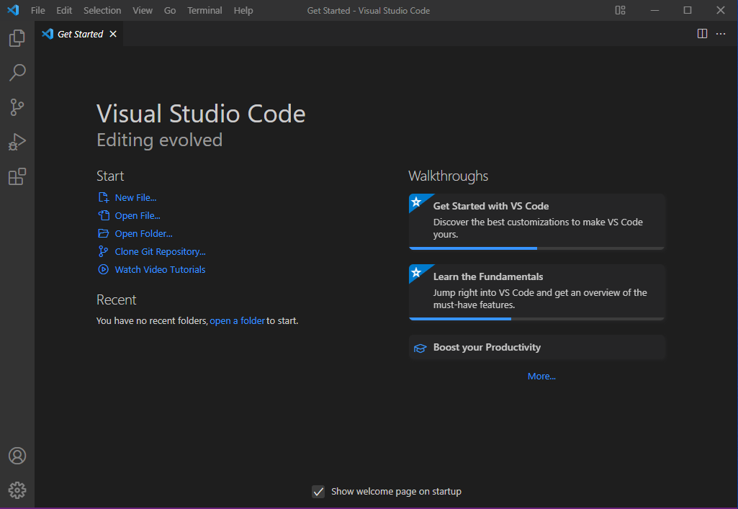

1. this is how we successfully installed **Visual Studio Code** on our Windows system.

## B. Node.JS - The steps to install Node.JS are as below

1. Downloading the Node.js ‘.msi’ installer.
2. The first step to install Node.js on windows is to download the installer. Visit the official Node.js website i.e.) <https://nodejs.org/en/download/>and download the .msi file according to your system environment (32-bit & 64-bit). An MSI installer will be downloaded on your system.

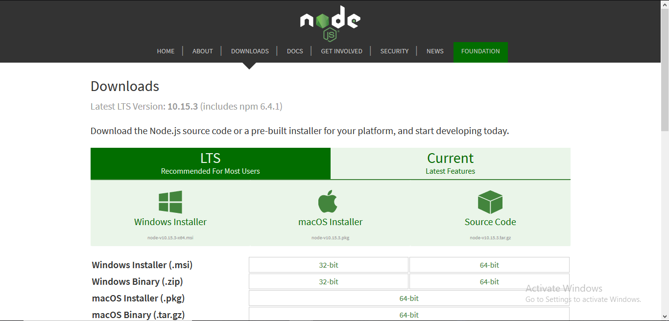

2. Double click on the .msi installer.

3. Welcome to Node.js Setup Wizard. ***Select “Next”***

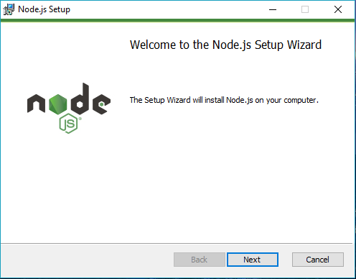

4. After clicking “Next”, End-User License Agreement (EULA) will open.

***Check “I accept the terms in the License Agreement”***

***Select “Next”***

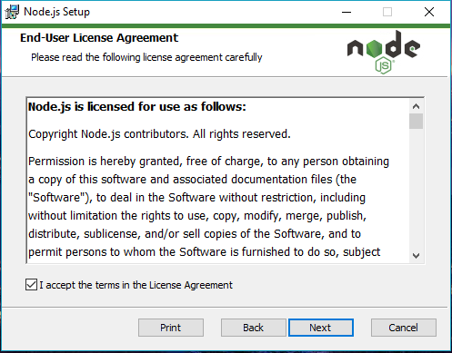

5.Destination Folder ***Set the Destination Folder where you want to install Node.js & Select “Next”***

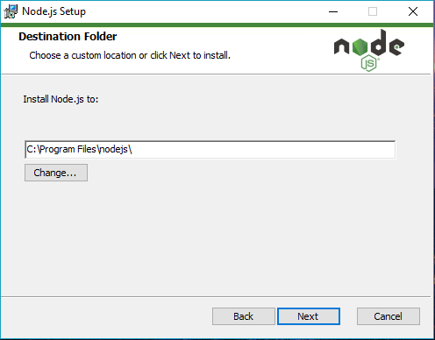

6. ***Select “Next”***

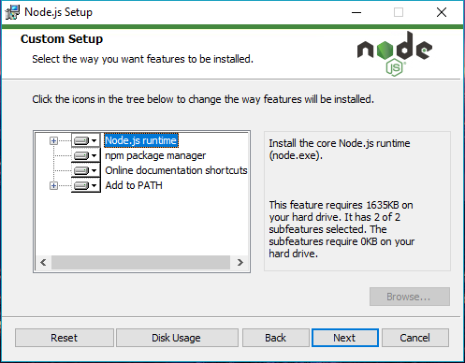

***7. Select “Install”***

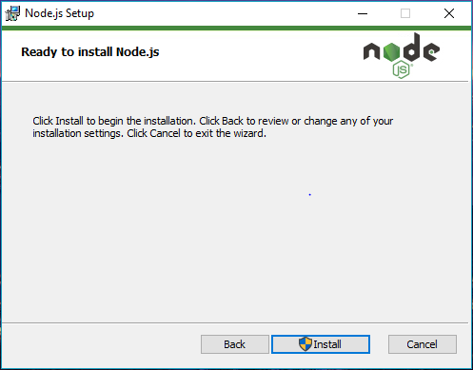

***8. Click “Finish”***

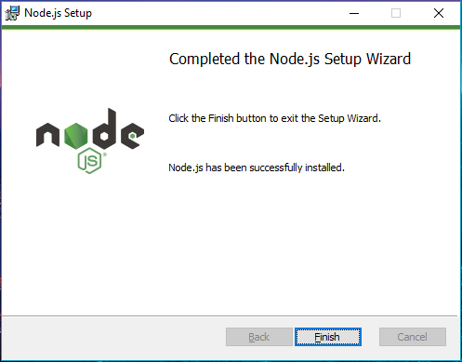

***9. Verify that Node.js was properly installed or not.***

***Verify using the following command***

***Command - node -v***

# Milestones

## Html

By making this application I have understood the basics of html, and I am able to implement its use case into other programs

## CSS

I have learned how to implement CSS in HTML code like using it for styling the HTML page etc.

## JAVASCRIPT

I have learned that JavaScript is a very good backend language, and many programmers should learn it and try its implementation as a server

## Server

I have also learned how to maintain a server by using googles inbuild development kit for chrome and during one of my alpha’s using MySQL as database

## Frontend

I have also learned about different kinds of frontend framework like react, Vue, next.js etc. although, I have not fully understood each one of them, but I am able to use them for frontend deployment

# Implementing the code

## Implementation of code using GitHub

1. To implement the note-app using git go to my GitHub page and go through the process stated in readme

## Implement manually

1. To manually implement the code you would be require to download it using the following link- <https://drive.google.com/file/d/1magIXoT3sWYW_DzWL0TbXY3oc0oX1WBz/view?usp=sharing>
2. Extract it
3. Open the folder in vs code
4. Open command prompt using shortcut CTRL+ shift+~
5. Type the following commands

npm init

npm install

## After that open your browser

1. Search GitHub click on the first link
2. Login or signup
3. Click on this link - <https://github.com/TheGamingWinner/Note-project>
4. On readme follow the rest of the steps

# Screenshot of my application

